CATS vs DOGS
CNN Hyperparameter Optimization with Keras Tuner
Executed-notebook Results and Methodological Review
REVIEW STATUS | EVIDENCE
Hyperband search | Completed: 30 trials; 1 hour 9 minutes 8 seconds
Final tuned training | Completed: 12 of 50 possible epochs (early stopping)
Recorded comparison | Available on validation split; NOT independent held-out test
Next recommended step | Rerun a leakage-free evaluation before claiming generalization gain

1 | Objective and Scope
Evaluate manual hyperparameter selection against automated Keras Tuner Hyperband search for binary image classification (Dog versus Cat). This report is based on the recorded execution outputs and code in Olfindo_JoPrisse_Loading_Dataset_and_CNN_Optimized.ipynb. It does not claim any additional experiments were executed.

2 | Dataset and Pre-Processing
The notebook reads PetImages.zip from Google Drive and uses the Dog and Cat folders. Images were loaded with OpenCV in grayscale, resized to 100 × 100, reshaped to a single channel, normalized to [0, 1], and shuffled before model training.

ITEM | OBSERVED VALUE
Usable Images | 24,997
Class Mapping | Dog = 0; Cat = 1
Tuner Training Split | 19,997 images
Tuner Validation Split | 5,000 images
Separate Independent Test Set | Not created in this run

3 | Model Configurations
PARAMETER | MANUAL CONFIGURATION | KERAS TUNER SELECTED
Convolution blocks | 3 | 4
Filters | 2 / 64 / 64 | 96 / 224 / 192 / 32
Kernel sizes | 3 × 3 / 3 × 3 / 3 × 3 | 3 × 3 / 3 × 3 / 5 × 5 / 3 × 3
Dense hidden units | 64 / 64 (linear) | 224 (ReLU)
Dropout | Not used | 0.1
Optimizer | Adam (default LR 0.001) | RMSprop (LR ≈ 0.001329)
Batch size | 128 | 64
Training epochs | 5 | 12 of 50 (early stopped)
Trainable parameters | 452,053 | 1,583,937

Inactive search-space values may still appear in the tuner output. For example, dense_units_1 = 32 was listed, but the selected model used one dense hidden layer, so this second-layer value was not active.

4 | Hyperparameter Tuning Procedure
The notebook uses kt.Hyperband with objective="val_accuracy", max_epochs=15, factor=3, and default one Hyperband iteration. A CNNHyperModel exposes convolution counts and filter sizes, kernel sizes, number and size of dense layers, dropout, learning rate, optimizer, and batch size. EarlyStopping monitors validation loss with patience=3 during search. All 30 scheduled trials finished.
Best recorded search validation accuracy: 88.76%. Total search time: 1:09:08. The winning architecture was rebuilt and trained with EarlyStopping (patience=5, restore_best_weights=True) and ReduceLROnPlateau. The final fit stopped after 12 epochs. Its last logged training accuracy was 99.49%, while validation accuracy was 88.76%, suggesting overfitting in the late epochs.

5 | Recorded Performance Comparison
The notebook later evaluated both trained models on X_val (5,000 images) and printed the following figures. These are recorded validation-split results, not unseen-test-set performance.
METRIC | MANUAL CNN | TUNED CNN
Accuracy | 81.30% | 87.36%
ROC AUC | 0.9002 | 0.9486
Accuracy difference | — | +6.06 percentage points
AUC difference | — | +0.0484
Final model training | 5 epochs | 12 epochs; best val_loss weights restored

The tuned model’s confusion matrix on X_val was [[2146, 354], [278, 2222]] (rows = actual, columns = predicted; Dog then Cat). This corresponds to 4,368 correct predictions out of 5,000 = 87.36% accuracy. The tuned model’s ROC AUC was 0.9486.
The training record shows a validation-loss minimum around epoch 7 (0.2971). Later epochs reached higher raw validation accuracy but increasingly worse validation loss; restoring the epoch with the best loss helps explain why final prediction-based accuracy (87.36%) is below the highest logged value (88.76%).

6 | Interpretation and Methodological Limitations
Data overlap / leakage. The manual CNN was fitted with model.fit(X, y, validation_split=0.2) before a separate train_test_split(X, y, test_size=0.2) was created for tuning. Because the two partitions were defined independently, the later X_val includes images previously used for manual-model training. Its 81.30% figure therefore cannot be considered an independent validation estimate for the manual model.
Validation-set selection bias. X_val was used both for choosing hyperparameters and for early stopping / learning-rate adjustment in the tuned model. A final score on X_val is not the same as performance on a never-used test set.
Different training budgets and model complexity. The manual run trained for 5 epochs, whereas the final tuned CNN ran 12 epochs, and the tuned architecture has approximately 3.5 times as many trainable parameters. The observed difference reflects these combined changes, not hyperparameter-search strategy alone.
Overfitting. Late-epoch training accuracy approached 99.49% while validation loss increased. The notebook correctly employs EarlyStopping, but this gap still warrants discussion.
Consequently, the recorded +6.06-point validation difference describes this execution; it should not be presented as a definitive generalization improvement, a statistical significance result, or a test-set score.

7 | Recommended Fair Follow-Up Experiment
Use a single fixed, stratified train / validation / test split created BEFORE fitting either model (for example, 70% / 15% / 15%). Train the manual CNN only on training data, search tuned configurations using the same training and validation splits, train the best tuned model, and evaluate both once on the untouched test split. Use identical preprocessing and preferably comparable final training budgets. Report accuracy, precision, recall, F1, ROC AUC, confusion matrices, and training costs. These revised results would replace the preliminary figures in Section 5 for the final academic comparison.

8 | Conclusion
Automated Hyperband tuning completed and found a larger CNN configuration with a high recorded validation accuracy. The trained tuned CNN obtained 87.36% accuracy and 0.9486 ROC AUC on the tuner validation split, compared with the manual model’s recorded 81.30% and 0.9002 on those same images. These observations support further testing of the tuned architecture, while the overlap and tuning-on-validation issues prevent a conclusive head-to-head claim until a clean held-out evaluation is performed.

9 | Evidence from the Executed Notebook

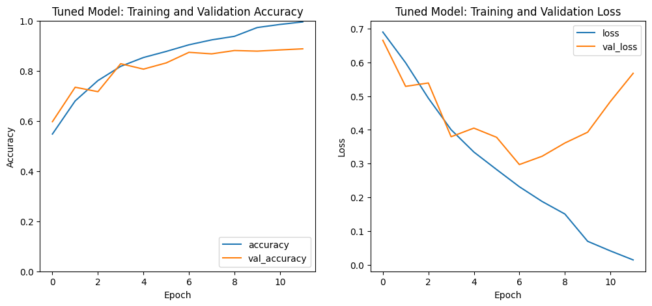
Figure 1. Tuned-model Accuracy and Loss during Final Training (Executed Notebook Output)

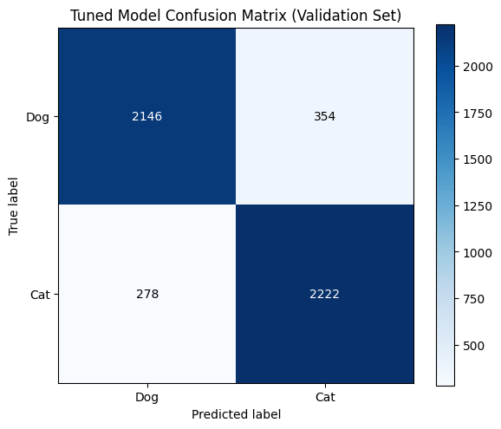  Figure 2. Tuned CNN Validation Confusion Matrix | 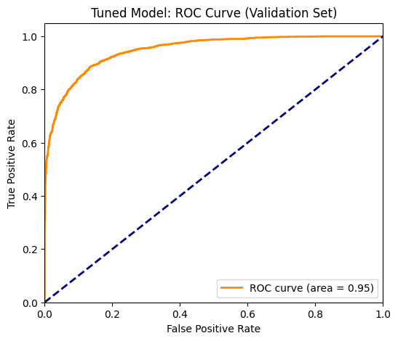  Figure 3. Tuned CNN Validation ROC Curve

References and Reproducibility Note
Primary Evidence: Olfindo_JoPrisse_Loading_Dataset_and_CNN_Optimized.ipynb (uploaded, executed notebook); Original Instructional Notebook Attributed therein to Doc. Rolando A. Pula.
KerasTuner Documentation: https://keras.io/keras_tuner/ . Hyperband API: https://keras.io/keras_tuner/api/tuners/hyperband/ . Dataset referenced by notebook: Kaggle Dogs vs. Cats / PetImages.
All reported values come from the uploaded notebook outputs; No fresh model training was performed for this document. The report should be updated after an independent test-set experiment if the assignment requires a fair performance comparison.

